Part C

1. Explain the typical machine learning techniques looks for pattern in data and recommends some action based on what it finds.
2. Explain the continuous machine learning process in hypothesis generation and scoring in detail.
3. Identify the techniques, rules and pattern used by the NLP to make interferences about meaning in a text document and explain it.
4. Explain the different models to represent knowledge in detail.
5. Design the cognalytics using open libraries tools and describe the implementation layer-wise starting from the bottom layer.
6. Explain any four standard machine learning (ML) algorithms that are widely used in cognitive analytics.
7. Justify how to answer the business questions in new ways for building business specific solutions to make cognitive computing a reality and cognitive application changing the market in detail.
8. Define the ways to ensure and expand that the cognitive applications delivering accurate information to provide the right level of insight. Elucidate your views in detail.
9. Design and build a cognitive application in healthcare with the required steps.
10. Design interactive system for predicting student performance and explain its components.
11. What are the components of cognitive computing system? Write down its functional details in the architecture of cognitive computing system.
12. What is Kahneman's theory? How does it is related to cognitive computing system? Discuss his approach to the design of two systems.
13. Write about the following in natural language processing:

(i) Lexical analysis

(ii) Syntactic analysis

(iii) Discourse analysis

(iv) Pragmatics

1. Describe the knowledge representation models, taxonomies and ontologies with an example.
2. Discuss in detail about the architecture of cognalytics with its diagram.
3. Write about the following machine learning algorithms with respect to the cognitive analytics.

Logistic regression

Decision trees

Deep learning

Bayesian networks

1. What are the advantages of cognitive system approach for solving the business problems?
2. Write the cognitive system approach for constructing future plan by using business knowledge.
3. Explain about the seven key steps to design a cognitive computing system for an application.
4. Discuss atx»ut the following different paths for implementing of cognitive health care applications.

(i) User engagement applications

(ii) Discovery applications

1. What are the importance of learning analytics? Explain the importance of learning analytics module in educational data mining with an example.
2. Give the description of history of cognitive science and analyze how does the brain receive process and respond to sensory input.
3. Analyze and compare artificial intelligence and psychology to determine how the brain integrates sensory input.
4. Explain, analyze, compare and classify the neural network models.
5. 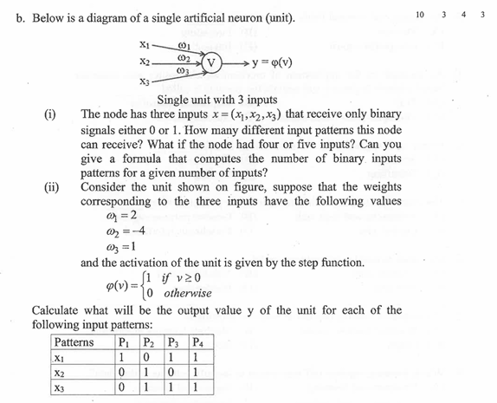
6. Give the syntax and semantics in linguistics in detail and analyze how does the brain learn and the language.
7. Write in detail about the cognitive and emergent systems and analyze how the phases of natural language processing is incorporated in robotics.
8. Write a description about the following

(i) Affordances

(ii) Direct perception

(iii) Ecological psychology

And analyze how the affordances are used in web design

1. Analyze how the affordance based imitation learning in robots is done.
2. Analyze a concept learning task to find out an inductive learning hypothesis.
3. Write about the categories of machine learning algorithms and give a comparative analyzer.
4. Explain the typical machine learning techniques looks for pattern in data and recommends some action based on what it finds.
5. Explain the continuous machine learning process in hypothesis generation and scoring in detail.
6. Explain the different models to represent knowledge in detail.
7. Design the cognalytics using open sources libraries tools and describe the implementation layer-wise starting from the bottom layer.
8. Explain any four standard machine learning (ML) algorithms that are widely used in cognitive analytics.
9. Justify how to answer the business questions in new ways for building business specific solutions to make cognitive computing a reality and cognitive application changing the market in detail.
10. Define the ways to ensure and expand that the cognitive applications delivering accurate information to provide the right level of insight. Elucidate your views in detail.
11. Design and build a cognitive application in healthcare with the required steps.
12. Design interactive system for predicting student performance and explain its components.